**(Q-1)• List out the platforms available for Social Media Marketing.**

**ANS:-**

**Mainstream:**

* Facebook
* Instagram
* Twitter
* LinkedIn
* YouTube
* Reddit

**Visual-Centric:**

* Flickr
* Vimeo
* Tumblr
* DeviantArt
* Behance

**E-commerce:**

* Shopify
* Amazon
* Etsy
* eBay
* WooCommerce

**Influencer:**

* AspireIQ
* Upfluence
* HYPR

**Management Tools:**

* Hootsuite
* Sprout Social
* Buffer

**Analytics:**

* Google Analytics
* Facebook Insights
* Twitter Analytics

**(Q-2) How many types of content we can use for Social Media Marketing? Explain any three.**

**ANS:-**

**Types of Social Media Content:**

* Visual Content (images, videos, infographics)
* Text-Based Content (posts, articles, blogs)
* Interactive Content (polls, quizzes, contests, surveys)

**Other types:**

* Audio Content
* Video Content
* User-Generated Content
* Influencer Content
* Educational Content
* Emotional Content
* Promotional Content

**(Q-3) Why should we use Social Media Marketing to promote our business?**

**ANS:-**

**Benefits:**

* Increased Brand Awareness
* Targeted Audience Reach
* Improved Website Traffic
* Enhanced Customer Engagement
* Cost-Effective Advertising
* Competitive Advantage
* Data-Driven Insights
* Improved Customer Service
* Increased Sales and Conversions
* Global Reach

**Why Social Media Marketing?**

* 4.2 billion active users worldwide
* 70% of online adults use social media
* Average user spends 2.5 hours/day on social media
* 71% of consumers recommend brands after positive social media experiences

**Invest in Social Media Marketing to:**

Grow your business

Boost online presence

Drive sales and revenue

Stay ahead of competitors

It's essential for businesses to leverage social media marketing to reach, engage, and convert their target audience.

**(Q-4)What is the relationship between SEO and Social Media Marketing**

**ANS:-**

**SEO Benefits for Social Media:**

* Improved visibility
* Increased website traffic
* Enhanced credibility

**Social Media Benefits for SEO:**

* Social signals (likes, shares)
* Content promotion
* Link building
* Local SEO enhancement

**Shared Goals:**

* Online visibility
* Website traffic
* Leads and sales
* Brand awareness

**Integration Strategies:**

* Share blog posts
* Optimize profiles
* Use keywords
* Analyze social media insights
* Leverage influencer

**(Q-5) Prepare a word file in which you should add:**

**o Type of content to create on YouTube for** [**http://www.designer2developer.com**](http://www.designer2developer.com)

**o Suitable topic list for http://www.designer2developer.com according to your research on Google trends**

**o List out the points to include in the video**

**o Suitable title and description for the video o Keywords to target and its placement**

**ANS-:**

**I. Type of Content to Create:**

* Educational/Tutorial videos
* Case studies/Success stories
* Product demos
* Webinars
* Industry news/Updates

**II. Suitable Topic List (based on Google Trends research):**

* IoT Development
* Mobile App Development
* Web Development
* AI/Machine Learning
* UX/UI Design
* E-commerce Solutions
* Education Technology
* Blockchain Development
* Progressive Web Apps

**IV. Points to Include in the Video:**

* Introduction to IoT
* Benefits of Smart Home Systems
* Design considerations
* Development process
* Case study/example
* Challenges and solutions
* Future trends in IoT
* Conclusion/Call-to-action

**V. Video Title and Description:**

**Title:** "Building a Smart Home System with IoT: A Step-by-Step Guide"

**Description:** "Learn how to build a smart home system using IoT technology. Our experts at Designer2Developer share their expertise in designing and developing innovative IoT solutions. Watch till the end for a real-life case study!"

**VI. Keywords to Target:**

1. IoT development

2. Smart home system

3. Mobile app development

4. UX/UI design

5. Healthcare technology

6. E-commerce solutions

7. Artificial intelligence

8. Machine learning

**VII. Keyword Placement:**

1. Video title

2. Video description

3. Tags

4. Thumbnail image (text overlay)

5. Closed captions/subtitles

**(Q-6) What are tools we can use for Marketing on a platform like Facebook and Instagram?**

**ANS:-**

**Facebook Tools:**

* Facebook Ads Manager
* Facebook Insights
* Facebook Pixel
* Facebook Groups
* Facebook Messenger

**Instagram Tools**:

* Instagram Insights
* Instagram Ads
* Instagram Stories
* Instagram Reels
* Instagram Shopping

**Third-Party Tools:**

* Hootsuite
* Buffer
* Sprout Social
* Canva
* Adobe Creative Cloud

**Categories:**

* Advertising (Facebook Ads, Instagram Ads)
* Analytics (Facebook Insights, Instagram Insights)
* Content Creation (Canva, Adobe)
* Social Media Management (Hootsuite, Buffer)
* Influencer Marketing (AspireIQ, Upfluence)

**(Q-7) What type of traffic you will get on platform like Linked-In?**

**Demographics:**

**ANS:-**

* Professionals
* Business owners
* Decision-makers
* Industry experts
* Job seekers

**Intent:**

* Networking
* Job searching
* Industry research
* Professional development
* B2B marketing

**Benefits:**

* B2B leads
* Networking
* Brand visibility
* Website traffic

**(Q-8) Create social media presence (page or account) which helps your website and blog.**

**ANS:-**

**Facebook link:**

https://www.facebook.com/magicphotographystudio

**linkdin link :** https://www.linkedin.com/company/104954273/admin/dashboard/

**(Q-9) Prepare an excel sheet for posts of www.esellerhub.com to publish on Facebook, Instagram and Linked In.**

**ANS :-**

**(Q-10) What is the use of E-mail marketing?**

**ANS-**

**Main Objectives:**

* Lead generation
* Conversion and sales
* Brand awareness
* Customer retention
* Relationship building

**Benefits:**

* Targeted audience
* Cost-effective
* Measurable results
* Increased conversions
* Improved engagement

**Types:**

* Newsletters
* Promotional emails
* Transactional emails
* Automated sequences

**(Q-11)What goals you can achieve with the help of email marketing?**

**ANS-**

**Primary**:

* Generate Leads
* Drive Sales
* Build Brand Awareness
* Improve Customer Retention
* Enhance Engagement

**Secondary**:

* Nurture Prospects
* Re-engage Customers
* Reduce Cart Abandonment
* Improve Loyalty
* Gather Feedback

**Long-term:**

* Customer Loyalty Programs
* Thought Leadership
* Referral Programs
* Increase Lifetime Value
* Improve ROI

**(Q-12) Set-up an automation email for www.esellerhub.com abandon cart.**

**o Suggest a Subject for the email.**

**o Prepare an email**

**ANS-**

**Ans :-**

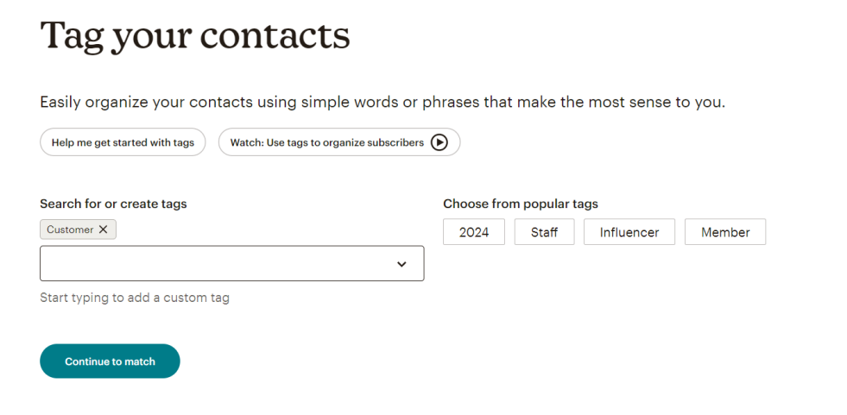

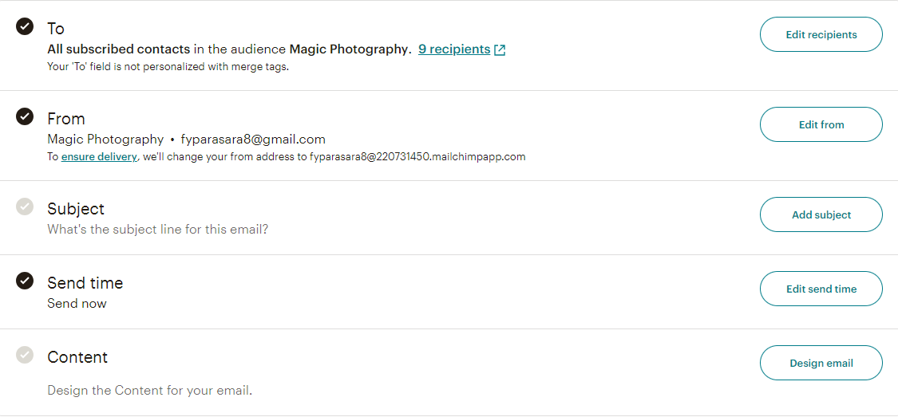

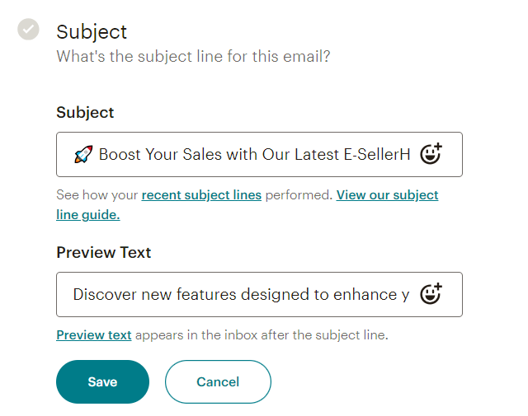

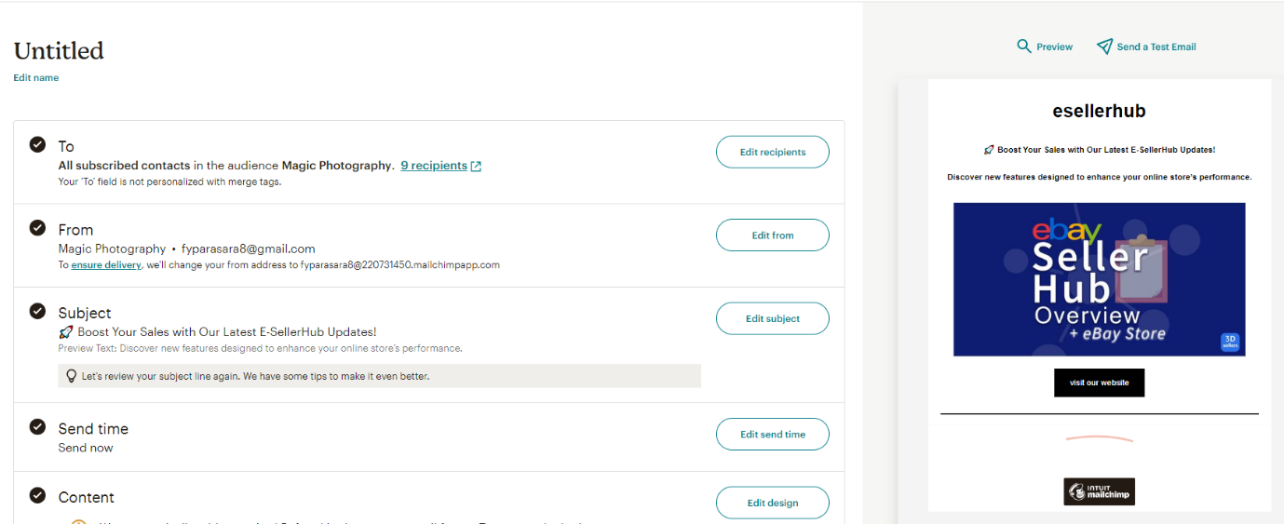

**(Q-13)Create Sign-up / Subscriber pop-up form for your blog and website using email marketing tools to collect audience data.**

**ANS-**

[**https://magicphotography1.blogspot.com/**](https://magicphotography1.blogspot.com/)

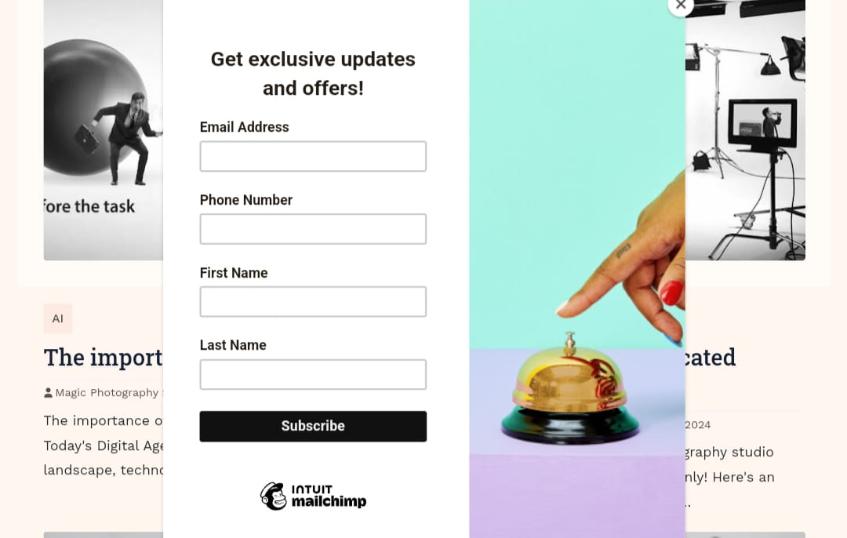

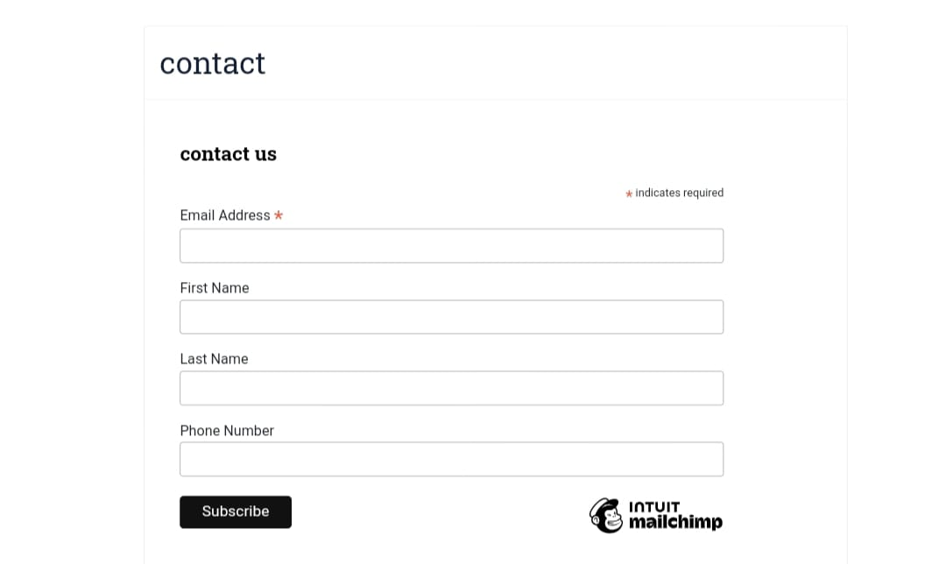

**(Q-14)What is affiliate Marketing?**

**ANS-**

**Affiliate Marketing:**

**Performance-based marketing:**

**Merchant + Affiliate + Customer**

**Benefits:**

* Low costs
* Passive income
* Flexibility
* Scalability

**Types:**

* Pay-per-Sale
* Pay-per-Lead
* Pay-per-Click

**Popular Programs:**

* Amazon
* ShareASale
* ClickBank
* Commission Junction
* Rakuten

**(Q-15) List some famous websites available for affiliate marketing.**

**ANS-**

* Amazon Associates
* ShareASale
* ClickBank
* eBay Partner
* Rakuten

**Digital:**

* JVZoo
* WarriorPlus
* PayDotCom

**Travel:**

* Expedia
* TripAdvisor
* Airbnb

**Other:**

* Shopify
* Microsoft
* Apple
* Google
* IBM

**(Q-16) Which are the platforms you can use for affiliate marketing**

**Networks:**

**ANS-**

* Amazon Associates
* ShareASale
* ClickBank
* Commission Junction
* Rakuten

**Social Media:**

* Instagram
* YouTube
* Facebook
* Twitter

**Content Platforms:**

* WordPress
* Blogger
* Medium

**Email Marketing:**

* Mailchimp
* ConvertKit
* AWeber

**Influencer Marketing**

* AspireIQ
* Upfluence
* HYPR

**E-commerce:**

* Shopify
* WooCommerce
* BigCommerce

**Tracking Tools:**

* Google Analytics
* Affiliate Tracker
* Voluum